**Concepts of Operating System**

**Assignment 2**

**------------------------------------------------------------------------------------------------**

**Part A**

What will the following commands do?

• echo "Hello, World!"

* It will print the same text which is written in the double quote.

• name="Productive"

* It will assign the string productive to the variable name.

• touch file.txt

* It will create the empty file.

• ls -a

* It will shows all files including hidden files.

• rm file.txt

* It will remove the file from directory.

• cp file1.txt file2.txt

* It will copy the contents of file1 to file2.

• mv file.txt /path/to/directory/

* It will move the file from current directory to directory whose path is given after file name.

• chmod 755 script.sh

* It will change the setting permissions of user to read, write and execute and group and other users permission to read and execute.

• grep "pattern" file.txt

* It will search for the word which is written in double quote.

• kill PID

* It will terminate the process.

• mkdir mydir && cd mydir && touch file.txt && echo "Hello, World!" > file.txt && cat file.txt

* It will create mydir directory. Then using cd command we change the directory to mydir. Then in mydir it will create one empty file called file.txt. After that using echo command we wrote a text Hello, World in file.txt. After that using cat command we display the content of the file.txt.

• ls -l | grep ".txt"

* It will list the information about files whose extension is .txt.

• cat file1.txt file2.txt | sort | uniq

* It will sort the content of both the files together and then print the unique content only.

• ls -l | grep "^d"

* It will display the information of directories in that directory.

• grep -r "pattern" /path/to/directory/

* It prints the filename and the matching line. It searches inside all files

• cat file1.txt file2.txt | sort | uniq –d

* It combines the data of both files and by sorting print the duplicate lines.

• chmod 644 file.txt

* It change the permissions of the file to user to read and write, and for group and other users to read only.

• cp -r source_directory destination_directory

* It will copy the all contents of source directory in destination directory.

• find /path/to/search -name "*.txt"

• chmod u+x file.txt

* It will change the permission setting of user to execute.

• echo $PATH

* It will show the list of directories.

**Part B**

--------------------------------------------------------------------------------------------------------------------------

Identify True or False:

1. ls is used to list files and directories in a directory.

- True

2. mv is used to move files and directories.

- True

3. cd is used to copy files and directories.

- False

4. pwd stands for "print working directory" and displays the current directory.

- True

5. grep is used to search for patterns in files.

- True

6. chmod 755 file.txt gives read, write, and execute permissions to the owner, and read and execute

permissions to group and others.

- True

7. mkdir -p directory1/directory2 creates nested directories, creating directory2 inside directory1

if directory1 does not exist.

- True

8. rm -rf file.txt deletes a file forcefully without confirmation.

**- True**

**Identify the Incorrect Commands:**

1. chmodx is used to change file permissions.

- chmod

2. cpy is used to copy files and directories.

- cp

3. mkfile is used to create a new file.

- touch filename / cat filename

4. catx is used to concatenate files.

- cat

5. rn is used to rename files.

- mv

**Part C**

**---------------------------------------------------------------------------------------------------------------------------**

Question 1: Write a shell script that prints "Hello, World!" to the terminal.

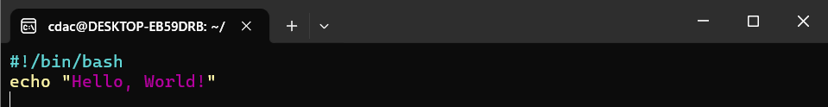

Question 2: Declare a variable named "name" and assign the value "CDAC Mumbai" to it. Print the

value of the variable.

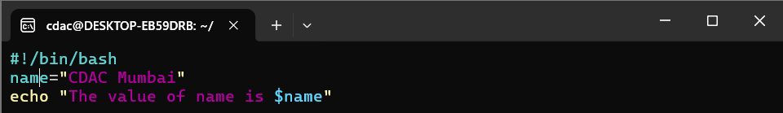



Question 3: Write a shell script that takes a number as input from the user and prints it.

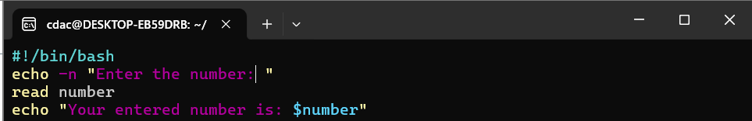

Question 4: Write a shell script that performs addition of two numbers (e.g., 5 and 3) and prints the

result. 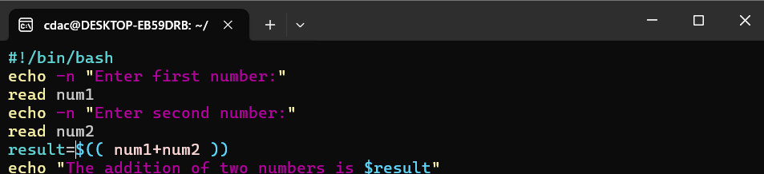



Question 5: Write a shell script that takes a number as input and prints "Even" if it is even, otherwise

prints "Odd".

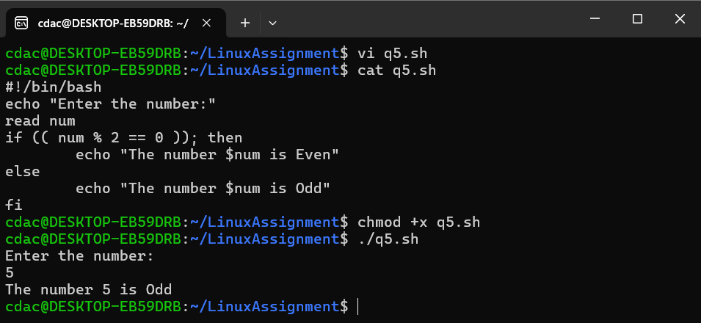

Question 6: Write a shell script that uses a for loop to print numbers from 1 to 5.

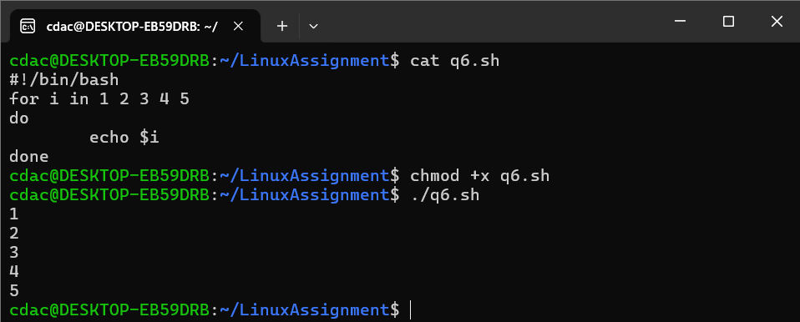

Question 7: Write a shell script that uses a while loop to print numbers from 1 to 5.

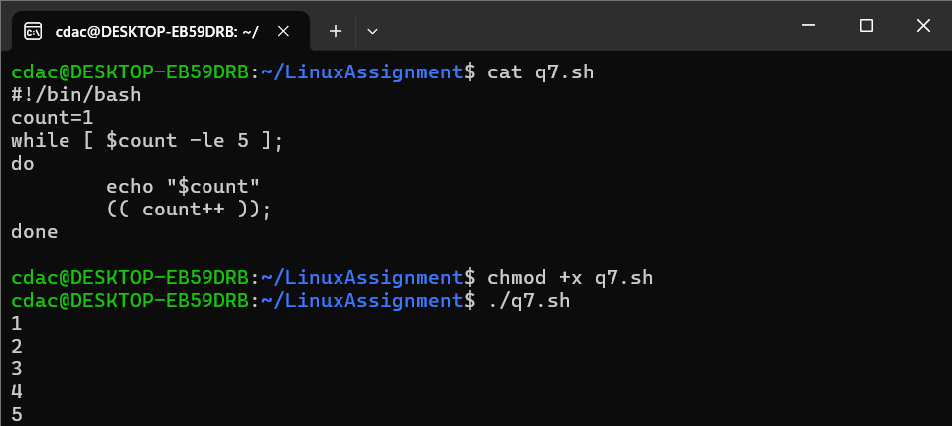

Question 8: Write a shell script that checks if a file named "file.txt" exists in the current directory. If it

does, print "File exists", otherwise, print "File does not exist".

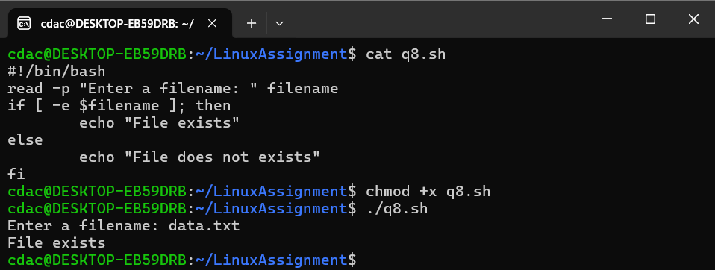

Question 9: Write a shell script that uses the if statement to check if a number is greater than 10 and

prints a message accordingly.

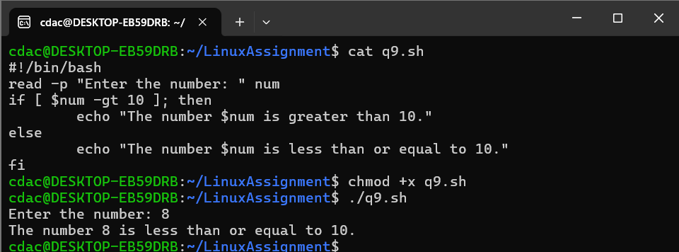

Question 10: Write a shell script that uses nested for loops to print a multiplication table for numbers

from 1 to 5. The output should be formatted nicely, with each row representing a number and each

column representing the multiplication result for that number.

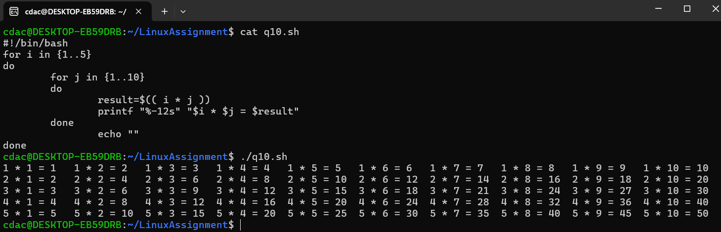

Question 11: Write a shell script that uses a while loop to read numbers from the user until the user enters a negative number. For each positive number entered, print its square. Use the break statement to exit the loop when a negative number is entered.

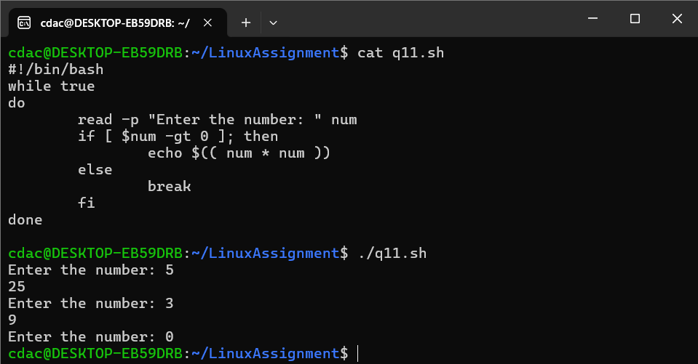

1. Consider the following processes with arrival times and burst times:

| Process | Arrival Time | Burst Time |

|---------|--------------|------------|

| P1 | 0 | 5

| P2 | 1 | 3

| P3 | 2 | 6

Calculate the average waiting time using First-Come, First-Served (FCFS) scheduling. 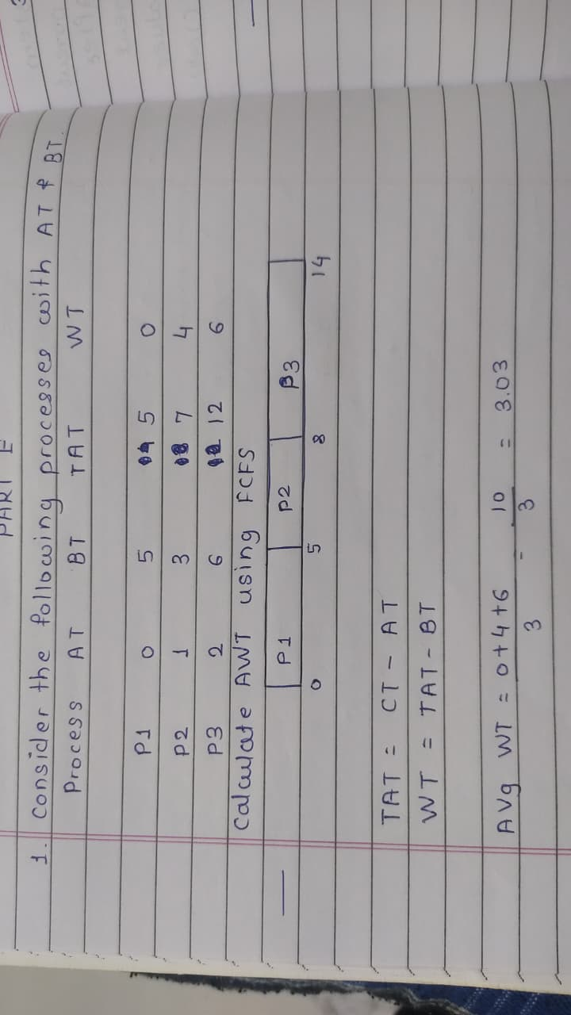

2. Consider the following processes with arrival times and burst times:

| Process | Arrival Time | Burst Time |

|---------|--------------|------------|

| P1 | 0 | 3

| P2 | 1 | 5

| P3 | 2 | 1

| P4 | 3| 4

Calculate the average turnaround time using Shortest Job First (SJF) scheduling.

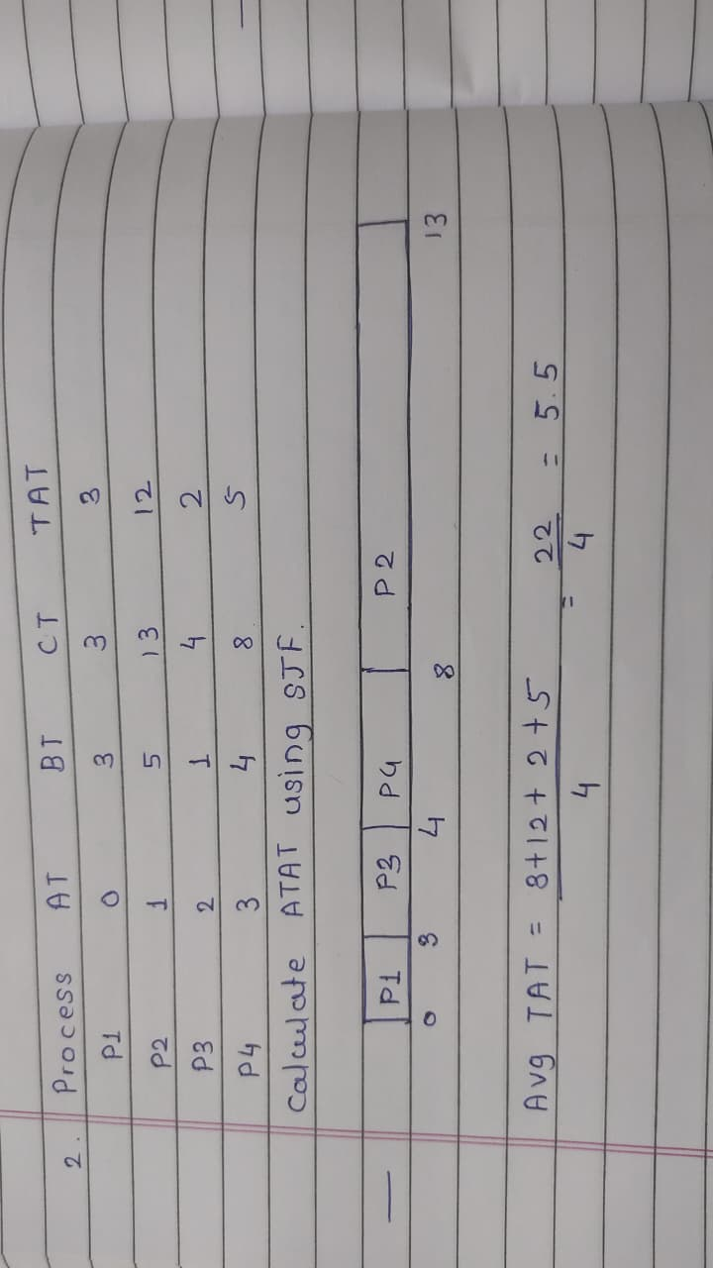

3. Consider the following processes with arrival times, burst times, and priorities (lower number

indicates higher priority):

| Process | Arrival Time | Burst Time | Priority |

|---------|--------------|------------|----------|

| P1 | 0 | 6 | 3 |

| P2 | 1 | 4 | 1 |

| P3 | 2 | 7 | 4 |

| P4 | 3 | 2 | 2 |

Calculate the average waiting time using Priority Scheduling. 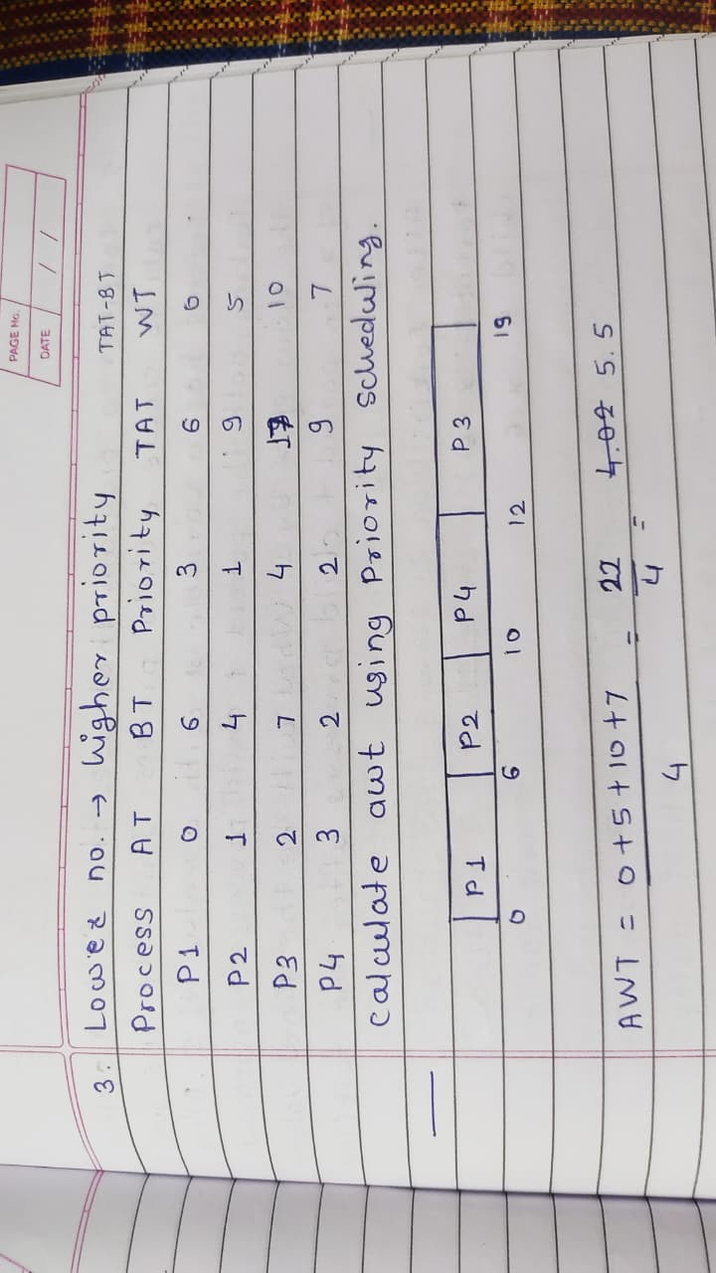

4. Consider the following processes with arrival times and burst times, and the time quantum for

Round Robin scheduling is 2 units:

| Process | Arrival Time | Burst Time |

|---------|--------------|------------|

| P1 | 0 | 4 |

| P2 | 1 | 5 |

| P3 | 2 | 2 |

| P4 | 3 | 3 |

Calculate the average turnaround time using Round Robin scheduling.

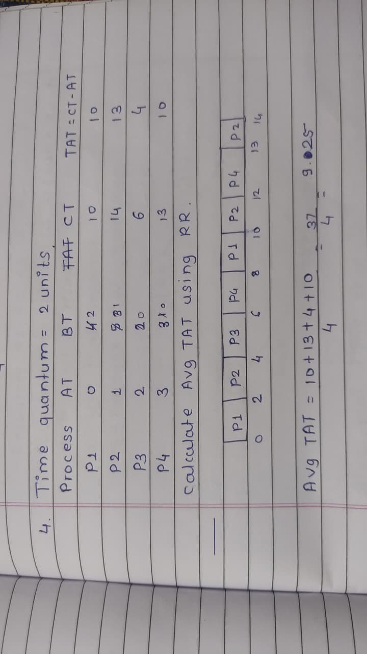

5. Consider a program that uses the fork() system call to create a child process. Initially, the parent

process has a variable x with a value of 5. After forking, both the parent and child processes

increment the value of x by 1. What will be the final values of x in the parent and child processes after the fork() call? 